**DAILY ONLINE ACTIVITIES SUMMARY**

|  |  |  |  |  |  |  |  |  |
| --- | --- | --- | --- | --- | --- | --- | --- | --- |
| **Date:** | **22/06/2020** | | | | | **Name:** | **Amrutha G** | |
| **Sem & Sec** | **4TH&A** | | | | | **USN:** | **4AL18CS006** | |
| **Online Test Summary** | | | | | | | | |
| **Subject** | | **N/A** | | | | | | |
| **Max. Marks** | | **N/A** | | **Score** | | | **N/A** | |
| **Certification Course Summary** | | | | | | | | |
| **Course** | 1. **BLOCKCHAIN BASICS** | | | | | | | |
| **Certificate Provider** | | | **GREAT LEARNING** | | **Duration** | | | **2.5 HOURS** |
| **Coding Challenges** | | | | | | | | |
| **Problem Statement 1: Write a java program to count number of bits to be flipped to convert A to B** | | | | | | | | |
| **Status: executed** | | | | | | | | |
| **Uploaded the report in Github** | | | | | **YES** | | | |
| **If yes Repository name** | | | | | **https://github.com/AMRUTHAGANESH/lockdown-java-codings-**  **https://github.com/AMRUTHAGANESH/lockdown-certification_course** | | | |
| **Uploaded the report in slack** | | | | | **YES** | | | |

**Online Test Summary: N/A**

**Online Certification course:**

Certification details: BLOCKCHAIN BASICS

Today I learnt chapter database vs block chain , role of intermediate and block chain of crypographic

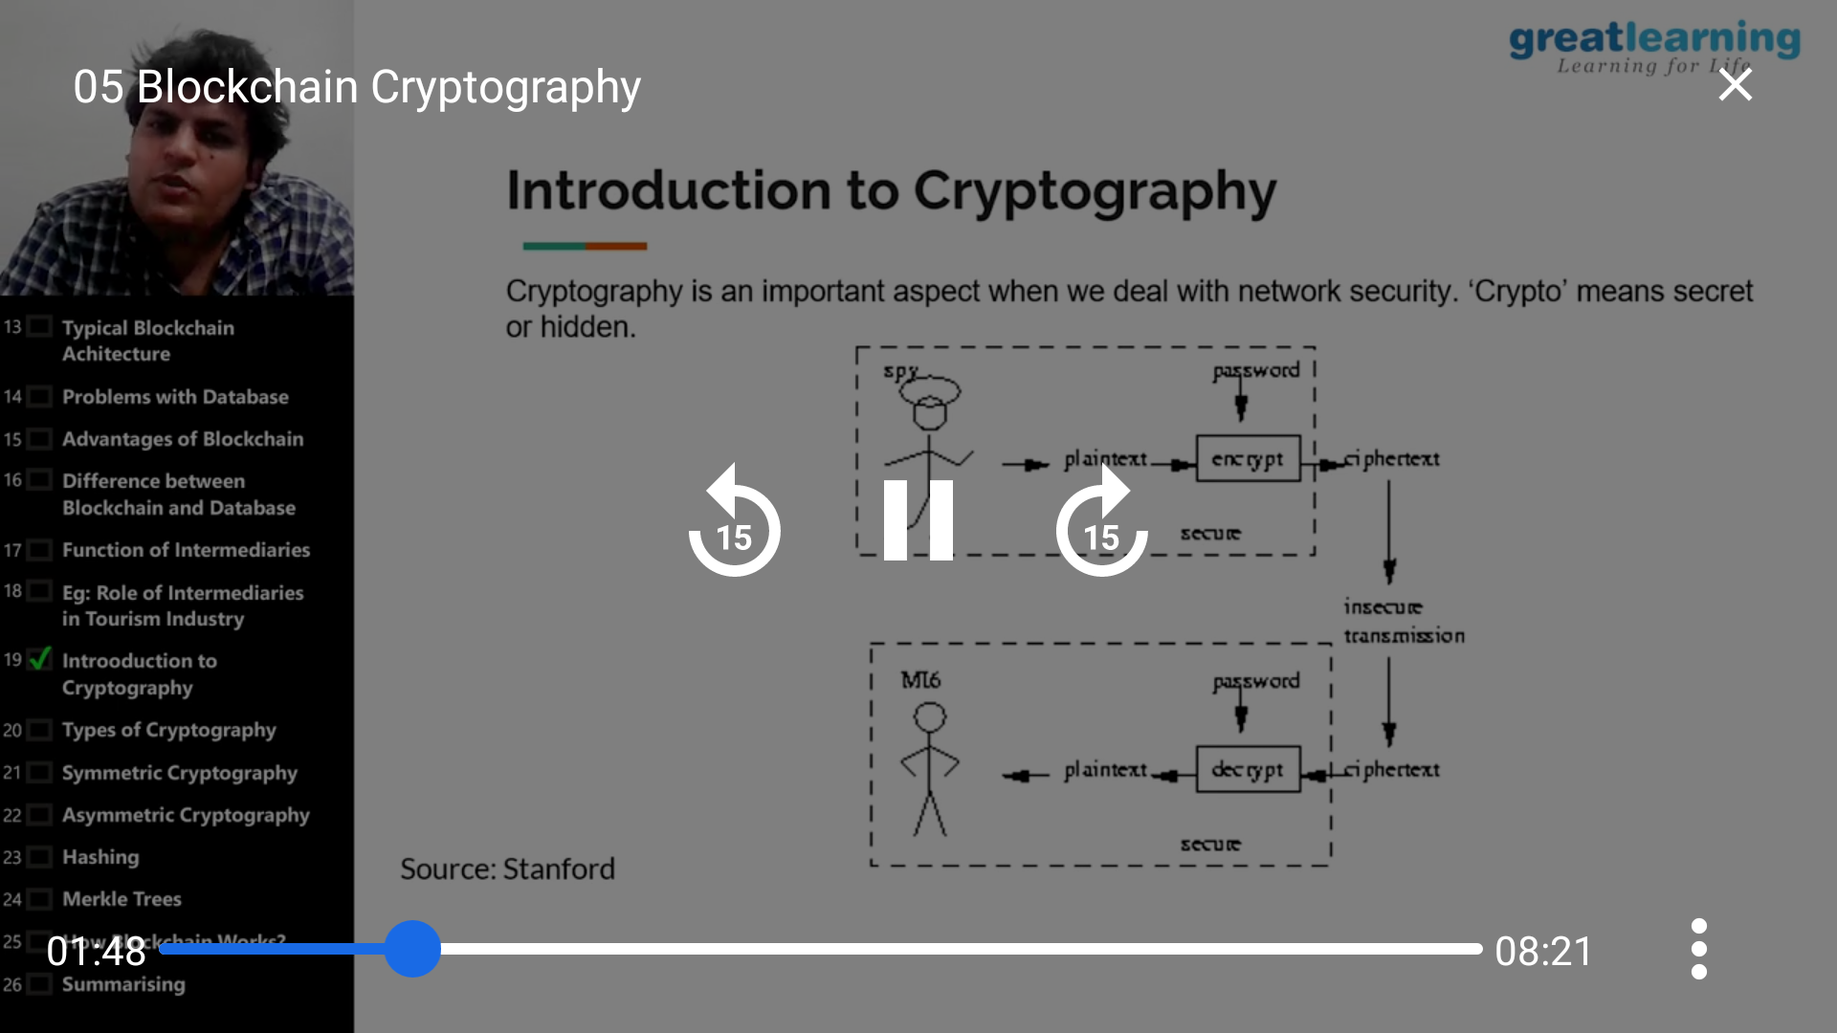

Online Coding summary:

1. **Write a java program to count number of bits to be flipped to convert A to B**

